WMCI Extra-Curricular Curling 2016-2017 November 22, 2016
Parents/Guardians:
Your child has registered to join curling for the 2016-2017 WMCI school year. Coaches for this year are Rob Melnyk and Sylvia Hayward – a BIG thank you for their willingness to handle coaching responsibilities.

The following dates have been scheduled. Your son/daughter will be required to travel by PCSD bus or pre-authorized private vehicle (parent/guardian driven) when necessary. *Be advised that sometimes changes occur to the schedule. Players will be notified of these changes in advance. If students are not able to attend a planned event (including practice), please inform your coach and Mrs. Lehmann as soon as possible.

* Attendance will be kept for all practices and games in order to accurately report to the Athletic Committee on Junior and Senior letter point accumulations.

Official practices will be Wednesdays from 3:45 – 5:15 at the Gladstone Curling Rink, beginning on November 23rd and continuing up to zone competition (not during Christmas break).

November 23
November 30
December 7
December 14
December 21
January 11
January 18
January 25
February 1
February 8

Zone Competition will be held on February 10 & 11, 2017 in Rivers (Friday & Saturday).
Provincial competition will be held in Dauphin from February 23-25, 2017 (Thursday – Saturday). We must qualify for Provincials by winning the Zone playoffs.
There may be exhibition games set up through the coaches/advisors throughout the season, but these are not yet scheduled.

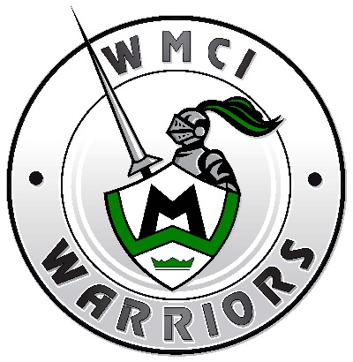

*This year the fee for this extra-curricular event is $40.00. The fee is to cover ice rental fees. A player will not be permitted to play until this fee has been paid or arrangements have been made with the school. It is not a participatory fee and does not reflect playing time. Please pay this fee prior to the first event listed above.

*The following items are provided by the school for this extra-curricular event: ___nil___
*Your son/daughter is responsible for all other items (equipment, clothing, etc).

Please complete the form below and return to Mrs. Lehmann as soon as possible.

WMCI Teacher Advisor: Nicole Lehmann (nlehmann@pinecreeksd.mb.ca) Home: 385-3753; Cell 870-1199

-------------------------------------------------------------------------------------------------------------------------------
_____ I have read the above and give permission for my son/daughter to travel by PCSD bus and/or pre-authorized private vehicles (parent driven) for events listed above.

_____ I have read the above and agree to the conditions outlined regarding the fee and equipment requirements.

__________________________ _____________________________ __________
Player Name Parent/Guardian Signature Date

